

RS Reports
Architecture

Revision History
Date | Version | Description | Author
04/01/11 | 1.0 | Created | Jim Heary
03/24/14 | 2.0 | Revised | Jim Heary

Table of Contents
Overview 4
Scope 5
Risks 5
Business Activities 5
Create Route Plan 6
Edit Route Plan 7
Receive Driver Paperwork 8
Receive Drivers 8
Manage Route Plan 9
System Analysis 10
Overview 10
Actors 10
Use Cases 11
Use Case 1 11
Use Case 2 11
Business Rules 11
Non-functional Requirements 11
Presentation 11
Performance 11
Security 12
Availability 12
Concurrency 12
Interoperability 12
Key Abstractions 12
States 12
System Design 13
Overview 13
Design Model 13
Structure 13
Behavior 14
User Interfaces 14
Persistence 14
Availability 14
Concurrency 14
Security 14
Deployment 15
Project Planning 16
Iteration 1 16
Appendix 17
Reports 17

Overview
This document describes the RS (Roadshow) Reporting System that provides reporting of Roadshow routing and planning activities in Argix Direct local terminals.

This document details known requirements and a candidate design. It does not address manpower requirements or project scheduling, although these can be determined from this architecture. Also, it does not cover Tsort integration as this is being addressed outside of this architecture.

How to read this document:
Management- Introduction, Analysis (Overview, Business Activities, Actors), Project Planning
Operations- Introduction, Analysis, Project Planning
IT- Introduction, Analysis, Design, Project Planning

Context
The following diagram provides context for the system under discussion. This is a high level view of the structure of the system; it helps us to understand the people, hardware, and external systems that interact with the system under discussion.

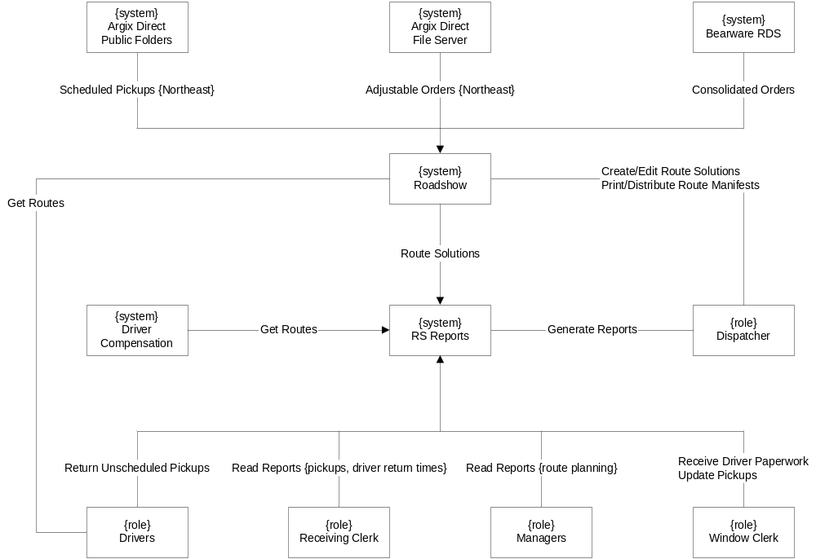

Scope
Solution Boundary
The solution will provide

Constraints
- The solution should conform to the principles of a Service Oriented Architectures (SOA).
- The solution will use the current Microsoft-based platform and Microsoft-based development tools.

Risks

Business Activities
The following diagrams show the business activities for the Pallet Shipment Program. Business activities are modeled using activity diagrams. Activity diagrams show a series of activities, the actors responsible for each activity, and the information consumed and created during the process. These diagrams use the language of the business. Activity diagrams drive the discovery of Actors, Use Cases, and Key Abstractions.

Create Route Plan
The diagram below shows the Create Route Plan activity. This activity is done once daily by the Dispatcher early in the morning (after midnight) or the prior night (before midnight). The Dispatcher uses the Windows Remote Desktop application to access the Roadshow front end server using a login designated for his terminal. He uses the Roadshow application to enter scheduled pickups from Public Folders (Northeast terminals only), import consolidated orders from the Bearware system, and import adjustable orders from file server (non-Northeast terminals only). He then generates a route solution from Roadshow. Next, the clerk runs reports from the RS Reporting application. Information regarding the initial (auto) route solution is captured and notifications are sent to management for the purpose of monitoring the activity.

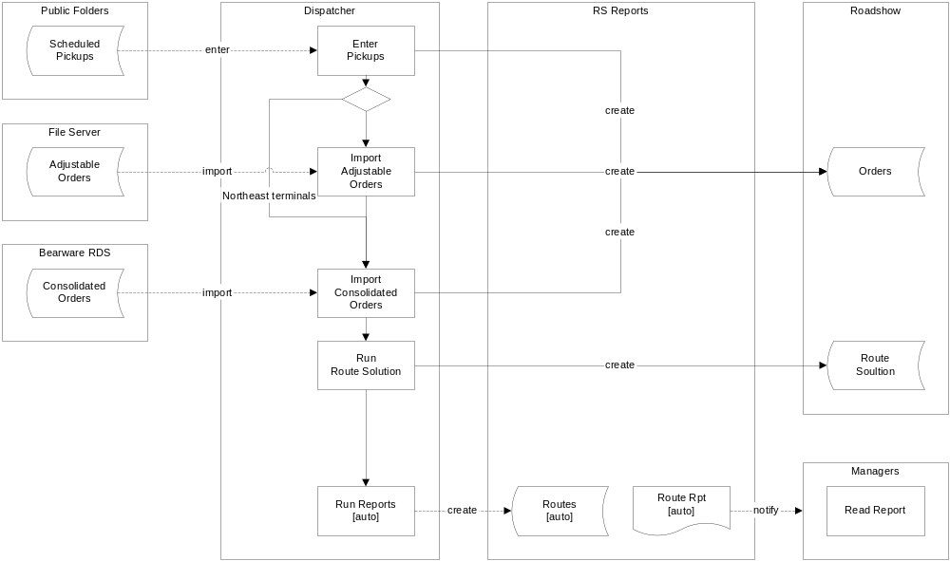

Edit Route Plan
The diagram below shows the Edit Route Plan activity. This activity is performed at least once daily by the Dispatch Clerk early in the morning (after midnight) or the prior night (before midnight). It is repeated as necessary to accommodate changes in scheduled pickups or consolidated orders. The Dispatcher edits the auto route solution using the Roadshow application until the route solution is complete and optimized. Next, the clerk runs reports (edit) from the RS Reporting application. A copy of the edit route solution is captured and a corresponding report is created. Information regarding the edited route solution is captured and notifications are sent to management for the purpose of monitoring the activity.

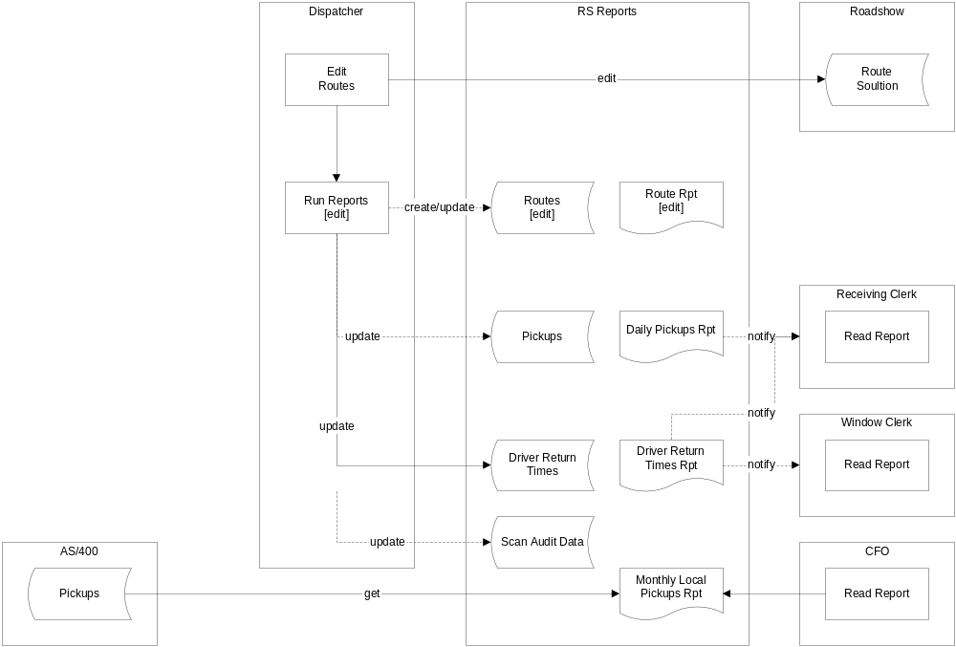

Receive Driver Paperwork
The diagram below shows the Receive Driver Paperwork activities.

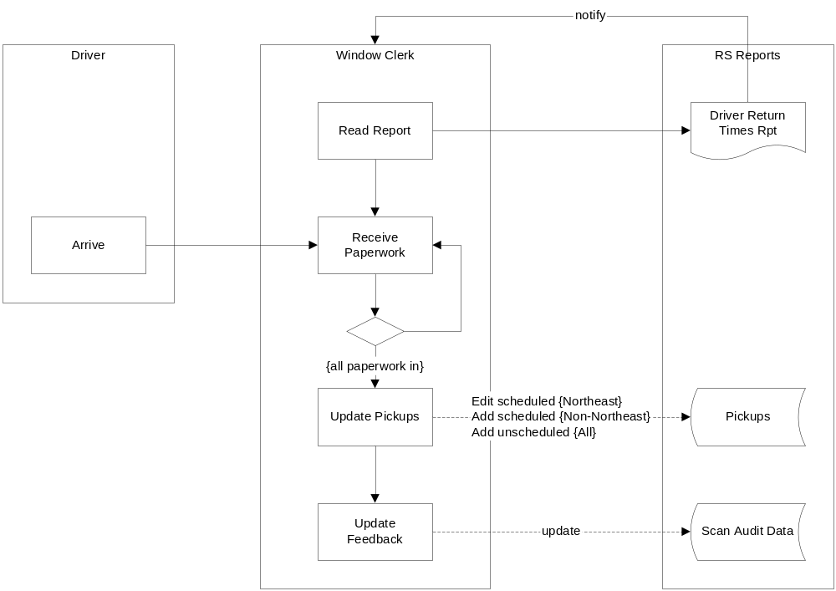

Receive Drivers
The diagram below shows the Receive Paperwork activities.

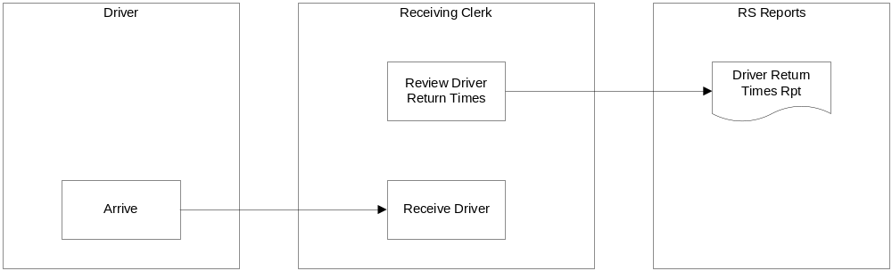

Manage Route Plan
The diagram below shows the Manage Planning activities.

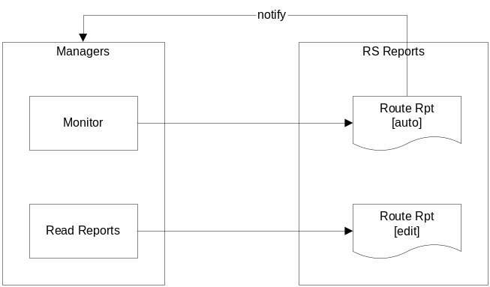

System Analysis

Overview
The purpose of defining system behavior is to discover, capture, and analyze the requirements of the system under discussion. This is achieved by describing the requirements (i.e. the conditions or capabilities to which the system must conform) well enough so that an agreement can be reached between the business users and the system developers on what the system should and should not do. It begins by modeling the business processes with a series of activity diagrams. These diagrams drive discovery of the users of the system (i.e. Actors), the system functionality (i.e. Use Cases), and the vocabulary of the system (i.e. Key Abstractions). From these artifacts, an analysis model is created that drives system design and development.

Actors
An actor specifies a role played by a user or any other system that interacts with the system under discussion. Actors influence UI design and security concerns. The list below provides definitions for the actors surrounding the Pallet Shipment system.
- Argix Direct Public Folders- public folders in the Argix Direct email system that contains lists of scheduled pickup orders for the Argix Direct local terminals in the Northeast (i.e. Ridgefield, South Windsor, and Wilmington). Pickup orders are centrally dispatched to Jamesburg and manually entered into the public folders by the National Dispatch Clerk.
- Argix Direct File Server- a file server that contains comma-delimited text files that represent order templates for the non-Northeast terminals which don’t import pickups from Argix Direct Public Folders.
- Bearware Retail Distribution System- a third party system that contains consolidated delivery orders for direct and indirect freight at the Argix Direct local terminals.
- Roadshow- a third party application that creates optimized route plans for driver deliveries and pickups in the Argix Direct local terminals.
- RS Reports- the reporting system to build
- Dispatcher- the Dispatcher in the local terminal is responsible for creating planned driver routes for local deliveries and pickups. He uses Roadshow to manually enter scheduled pickups from Public Folders, import adjustable orders from File Server, and import consolidated orders from Bearware. He uses RS Reports to capture route information and send notifications to management.
- Window Clerk- the Window Clerk in the local terminal is responsible for receiving driver paperwork for entering pickup information in RS Reports including updating scheduled pickups with actual values and adding unscheduled pickups.
- Receiving Clerk- the Receiving Clerk in the local terminal is responsible for receiving drivers and receiving freight from pickups using driver return times and pickup information from RS Reports.
- Drivers- drivers at the Argix Direct local terminals responsible for deliveries and pickups. The drivers execute the Roadshow Route Plan for local deliveries and scheduled pickups. In addition, unscheduled pickups are also made. Upon return to the local terminal, the driver submits freight from the scheduled and unscheduled pickups and associated paperwork.
- Management- Management includes the Director of Terminal Operations, the local Terminal Manager, and the Roadshow Specialist and they use information from RS Reports to manage, analyze, and improve driver route planning.

Use Cases
A Use Case is a list of steps, typically defining interactions between a role (i.e. Actor) and a system to achieve a goal. The actor can be a human or an external system. Use Cases describe the functional view of the system under discussion as a set of business transactions. Use Cases influence UI design, domain models, application service interfaces, and define business transactions. The following Use Case diagram shows some, if not all, of the actors and use cases involved in LTL Quote.

[Use Case Diagram]

Use Case 1
An Actor needs to

Use Case 2
Description
Pre-Conditions:
Pre-conditions
Flow of Events:
Basic Path

Alternative Paths
Alternative paths…

Post-Conditions:

Business Rules

Non-functional Requirements
Presentation

Performance

Security
Authentication
Employees will be authenticated by the Argix network domain.
Authorization
Role-based authorization (i.e. administrator, finance, operations) using domain accounts.
Availability
24-7.
Concurrency
Support up to 8 simultaneous users.
Interoperability
Roadshow- required to route shipment pickup and delivery in the local terminals. Roadshow services are exposed as SQL stored procedures.

Key Abstractions
The class diagram below shows the key abstractions involved in Pallet Shipment. Key abstractions are the key concepts and abstractions that the system needs to handle. They are those things that, without which, you could not describe the system. Key abstractions drive design of the database schema and the domain model (if applicable).

[Key Abstractions Diagram]

- Abstraction1-

States
The state machine view describes the dynamic behavior of objects over time by modeling the lifecycles of objects of each class. Each object is treated as an isolated entity that communicates with the rest of the world by detecting events and responding to them. Events represent the kinds of changes that an object can detect. Anything that can affect an object can be characterized as an event.

Abstraction1
Abstraction1 is in a new state...

[State Machine Diagram]

System Design

Overview
The system design includes

Design Model
Structure
The design is a n-tier physical and logical design composed of a .NET 4.0 Win Forms client (RSReports.exe), a .NET 4.0 WCF Services (Argix10.Terminal.Services), and a SQL Server 2008 R2 database. The design as a whole is built to conform to a Service Oriented Architecture. Service Oriented Architectures describe ways to build loosely-coupled systems composed from individual services. All software components are built with Microsoft Visual Studio 2010 and compiled to operate in.Net 4.0 framework environments. The structures of the design are defined by drawings of the components and interfaces. The behaviors of the design are defined by sequence diagrams involving the interactions between the components.

Enterprise Patterns
In software engineering, a design pattern is a general reusable solution to a commonly occurring problem within a given context in software design. It is a description or template for how to solve a problem that can be used in many different situations. Patterns are formalized best practices that the programmer must implement in the application. Object-oriented design patterns typically show relationships and interactions between classes or objects, without specifying the final application classes or objects that are involved. The following enterprise design patterns are used in throughout the design:

Transaction Script- a Transaction Script organizes business logic by procedures where each procedure handles a single request from the presentation. They are an excellent choice when we don’t have a middle tier domain model. Transaction scripts are used in the web services to provide business transactions and security for one or more use cases.
Gateway- a Gateway is an object that encapsulates access to an external resource such as a web service or database server. Gateways are used throughout the design for user interface access to middle tier web services, for web service access to backend database services, and for web service access to external hardware including a label printer.
Record Set- a Record Set is an in-memory representation of tabular data; record sets (i.e. DataSet) work well with .NET user interface components.
Data Transfer Object- a Data Transfer Object (DTO) is an object that carries data between processes in order to reduce the number of method calls. Data Transfer Objects are serialized classes exposed by the interfaces of the web services for transactional calls to the middle tier (i.e. LTLService::CreateShipper(Shipper shipper)).

RSReports Structure
The following drawing shows the components and interfaces (structure) of the RSReports design, and the connections between the various components. Components are denoted with tabbed containers. The rectangles within the components are software units stereotyped with their functional purpose such as a gateway or transaction script. There is a single user interface components: a Win Forms client (RSReports.exe). The user interface component uses the recordset for data caching; accesses the middle tier web service using a gateway. The Terminal web service (Argix10.Terminal.Services) exposes a single interface from a single transaction script: RSReportsService: IRSReportsService provides methods that support the use cases. The RSReportsService communicates with a RSReports database through a gateway; and to a web service front end (Argix10.Enterprise.Services) to an SMTP server through a gateway.

[Component Diagram]

Behavior
Behavior 1

User Interfaces
Windows Client
The windows application is built using .NET WinForms for the .NET 4.0 Framework. It communicates with a middle-tier Wcf service using the WcfHttpBinding binding. It is secured using an ASP.NET Membership services database through a Wcf Role Service.

The application is built using Visual Studio 2010 and is deployed onto a LAN-based IIS 7.5 web server where it is deployed to client computers using the Click-Once technology.

Persistence
Database Schema
The database schema is largely derived from the Key Abstractions. The following drawing shows the core schema required; what is not shown are tables concerning pallet rating and valid pickup/delivery locations.

The database is built and deployed with a SQL Server 2008 R2 database server. The schema is exposed through stored procedures.

[Database Schema Diagram]

Availability
As dictated by the platform.

Concurrency
There are no entities that require concurrent access.

Security
Authentication
Windows network login.

Authorization
The windows application uses ASP.NET role-based security to authorize access to application features and services. The RoleServiceGateway encapsulates the details to access the RoleService from the MembershipServices web service. The RoleServiceGateway also acts as a policy file where role-based access is queried by user interface objects. The following drawing shows the processes and components that realize the application authorization design.

[Authorization Diagram]

Deployment
The current deployment consists of a centralized application on the Jamesburg local area network (LAN) with client computers running on the Jamesburg LAN as well. Access to the application will be via the Argix Corporate Portal (i.e. SharePoint) using a Click-Once deployment that assumes the deployment server is always available; although the deployment is cached on the client, the server is always checked for a version update. Additional information concerning the click-once deployment can be found in the release notes accessible from the Help menu.

The deployment platform is as follows:
- Client- Windows7 operating system with .NET Framework 4.0 (full, not client)
- Web/Application Servers- Windows Server 2008 R2 and IIS 7.5 with .NET Framework 4.0
- Database Servers- Windows Server 2008 R2 and SQL Server 2008 R2
- Reporting Server- Windows Server 2008 R2 and SQL Server Reporting Services 2008 R2

[Deployment Diagram]

Project Planning

Iteration 1
Implement the following Use Cases:

Address the following risks:

Appendix

Reports
Report 1

[Report 1]

